PREFACE

Academic knowledge when augmented with the right practical exposure, serves as a double edged sword. It is very important to apply the academic knowledge in the practical life. If done so, education turns out to be worth. As bachelor students, our aim should not be only to learn theoretical concepts in the classroom but it becomes more important how we apply these concepts in practice.

In respect to the requirement of course prescribed by BKNMU University. We have finished our project to undertake the practical study of system analysis and design.

This project is on Desktop Professional and all the required details are included in the report. Care has been taken to take this project to maximum possible height at the same time maintaining the ease in interface.

This report is a chronicle of what we did at development. This report also consists of sample Screenshots and database design features. This report reflects the knowledge and the valuable insight gained during development.
We hope to be excused for any inadvertent omission or mistake.

ACKNOWLADGEMENT

It is matter of great pleasure for us to get this opportunity expressing our sincere sense of gratitude to BKNMU University. Firstly, I would like to express my heartly thanks to SSSDIIT College Junagadh for providing lab facility. My external guide Mr. Karmata Parbat ,Mr.Chirag Pandya.
Mr. Parbat Karmata and Mr.Dhaval Trivedi are the main force behind all these.
Because of them valuable suggestions and proper guidance for this project.

As the final words, we would like to thank all who have knowingly helped us in development of project.

Thank you to all!

-: Yours FaithFully :-
Gohel Hemang N.
Gauswami Nikul B.

INDEX

No. | Topic Name | Page No.
1 | Project Profile | 4
2 | Introduction | 5
3 | Project Summery | 6
4 | Hardware and Software Requirement | 7
5 | Project Scope | 8
6 | Tools And Technology | 9
7 | Project Cost Estimation | 13
8 | Methodology and Planning | 16
9 | System Analysis | 18
10 | Database Design | 22
11 | Prototype Model | 25
12 | Data Flow Diagram | 27
13 | Implementation | 32
14 | Testing | 33
15 | Screenshots and Coding | 35
16 | Biblography | 76

Project Profile

Title | Library Management System
Definition | Library Management System
Project Of | S.S.S.D.I.I.T. College-Junagadh
Developed By | Gohel Hemang & Gauswami Nikul
College | S.S.S.D.I.I.T. College – Junagadh
Director | Mr. Rushikesh Swami
Class | B.C.A. Semester – 5
Academic Year | 2019
Tools/Technology | IDE | Visual Studio | 2012
Tools/Technology | Back-End | MS ACCESS | 2013
Operating System | Windows 7,8,10 (All)
Project Duration | 3 Month
Team Strength | 2(Two)
Project Leader | Mr. Parbat Karamta  Mr. Dhaval Trivedi  Mr. Chirag Pandya

INTRODUCTION

Why your topic is important:-

- This Project Has Many Features of the Library Management System. It has, Images of Form, Employee and Customer Information.
- It gives the Information about the Employee,Customer,Routes Flights and Ticket etc.

Shortly describe the project:-
- This Project is on the Desktop of the Skyport Airlines. This Project Provides All the Details about the Skyport Airlines.
- It uses as Live Ticket Booking Software at Skyport Airlines.
- Airport authority uses this software as live but offline and on the spot Ticket Booking.
- This software is easy to use and Provide Speedy Access then website.

PROJECT SUMMERY

Academic knowledge when augmented with the right practical exposure, serves as a double edged sword. It is very important to apply the academic knowledge in the practical life. If done so, education turns out to be worth.

As bachelor students, our aim should not be only to learn theoretical concepts in the classroom but it becomes more important how we apply these concepts in practice.

In respect to the requirement of course prescribed by Saurashtra University. We have finished our project to undertake the practical study of system analysis and design.

This project is on Skyport Airlines and all the required details are included in the report. Care has been taken to take this project to maximum possible height at the same time maintaining the ease in interface.

This report is a chronicle of what we did at development. This report also consists of sample Screenshots and database design features. This report reflects the knowledge and the valuable insight gained during development.

We hope to be excused for any inadvertent omission or mistake.

HARDWARE SOFTWARE REQUIREMENTS

Hardware Requirement:-
Tools | Required
1.Processor | Intel p4 or higher
2.Hard disk | 40 GB or higher
3.RAM | 128 MB or higher
4.Other i/o device | Monitor

Software Requirement:-
Sr. No. | Software
1. | C#.NET
2. | MS SQL SERVER

PROJECT SCOPE

Features:-
We describe what features are in the scope of the Project and what are not in the Project for developed.
IN SCOPE :-
In This Site We Will Provide….
- Employee Registration
- Customer Information
- Ticket Booking
- Employee Information
- Route Information
- Flight Information

OUT SCOPE :-
These are the Limitations Of this Software .
- Not Book of Ticket Online.
- Limited Use.

TOOLS AND TECHNOLOGY

Frontend | Backend Tools | Other Tools
Visual Studio 2010(Ultimate)  (C#) | SQL Server 2008 | M.S. Word (2007,2003,2010)  Adobe Photoshop cs4,

What is .NET?
Microsoft .NET is a platform for developing “managed” software. The word managed is a key here.
The compiling to an executable file that contains machine code and how that file is loaded and executed by the operating system. Figure shows what I mean about the traditional compilation-to-execution process.

Source Code

Binary
Executable

Compiler

In the traditional compilation process, the executable file is binary and can be executed by the operating system immediately. However, in the managed environment of

.NET, the file produced by the compiler (the C# compiler in our case) is not an executable binary. Instead, it is an assembly, shown in Figure, which contains metadata and intermediate language code.

Source Code

Binary
Executable

Compiler

As mentioned in the preceding paragraph, an assembly contains intermediate language and metadata rather than binary code. This intermediate language is called Microsoft
Intermediate Language (MSIL), which is commonly referred to as IL. IL is a high-level, component-based assembly language.

  - SQL SERVER 2008 :-
Microsoft SQL Server is a relational database management system developed by Microsoft.
As a database, it is a software product whose primary function is to store and retrieve data as requested by other software applications, be it those on the same computer or those running on another computer across a network (including the Internet).
There are at least a dozen different editions of Microsoft SQL Server aimed at different audiences and for workloads ranging from small single-machine applications to large Internet-facing applications with many concurrent users.
Its primary query languages are T-SQL and ANSI SQL.
FEATURES OF SQL SERVER 2008:-
- Stability performance
- Manageability
- Back-up & recovery
- High availability
- Business intelligence
- Content management
- Security data integrity/triggers
- Information integration features

OTHER TOOLS
- Photoshop CS4:-
Adobe Photoshop promotes us to create a very attractive graphical page. With the help of this software, we can make really a good design in graphics. There are another software paint is also but the Photoshop is a very attractive project used to make a look of the picture.

We used Photoshop for making project report’s front-page for making the look

of the page very attractive. By the use of Photoshop, we can create many

shapes. Photoshop is very easy and provides a user-friendly.

PROJECT COST ESTIMATION

In early days of computing, software cost comprised a small percentage of overall computer-based system cost. An order magnitude error in estimates of software cost had relatively little impact. System a large cost estimation error can make the difference between profit and loss. Cost overcome can be disastrous for the developer.
Software cost and effort estimation will never be an extant science. Too many variable-human, technical, environments, political – can affect the ultimate cost of the software and effort and applied to develop it. However, software project estimation can be transformed from a mysterious art to series of systematic steps that provide estimates with expectable risk.

To achieve reliable cost and effort estimates, a number of options arise.
- Daily estimation until late in the project.
- Base estimates on similar projects that have all ready been completed.
- Use relatively simple “Decomposing techniques” to generate the project.
- Cost and effort estimates.
- Use one or more empirical models for software cost and effort estimation.

There are two methods available in “Software Engineering” to set the size of the project. Those methods are LOC (Line of Code) and FP (Function Point). With these both methods I can get approximate size of the project.

There are two methods available in “Software Engineering”, to get the approximate cost of the project. Those methods are COCOMO (Constructive Cost Model) and Empirical Estimation Methods. With these both methods we can get approximate cost of the project.

We have gone through COCOMO method to get approximate cost of the software project. Here we have given all the calculation done to get the approximate cost if this software project.

- COCOMO Method: -

To calculate efforts E the equation is,
E = 2.4+ (KLOC) ^1.05 = 2.4+ (1.82) ^1.05=4.50 per Month
To calculate time period T the equation is
T = 2.5+ (E) 0.38 = 2.5+ (4.50)0.38 = 4.42 Month
Average 4 months time
- Cost Estimation: -
Working time estimation is as given
3 months * 30 days/months = 90 days
3 hr / day = 270 hours
270 hours/3 months

Now, the expenses & cost estimation are given below:
Computer rent = 2500 /-
Light Bill Rs. 5/unit
(Worth 470 units) = 2350/-
+ Database design & creation = 3000 /-
+ Coding & Validation = 2000 /-
+ Documentation = 800 /-
Total = 10650 /-
Thus the approximate cost of this website project will be about 8100/= Rs.

METEDOLOGY AND PLANNING

GanttChart:

Specification
Design GUI Part
Code Database Part
Integrate and Test
Design Database Part
Code GUI Part
Documentation
July-05
July-20
Aug-04
Aug-17
Sept-01
Octo-01

Finish

- GANTT chart is a special type of bar-chart that describes that each bar describes a process or an activity.

- The length of the bar describes the time-allocated for the activity.
- When the more than one activity is done parallel this chart is very useful to understand the each process.

Pert Chart:

Finish
01-10-2014
Specification
05-07-2014
Integrate & Test
01-10-2014
Code Database-01-09-2014
Design Database
17-08-2014
5
Design GUI Part
04-08-2014

Code GUI
01-09-2014
Documentation
20-07-2014 to 01-10-2014

- A PERT chart is a project management tool used to schedule, organize, and coordinate tasks within a project.

- PERT stands for Program Evaluation Review Technique.

- PERT chart is very useful to show the project statistically. PERT chart is also very useful in the project assuming.

SYSTEM ANALYSIS

- Analysis is an important part of any project; is analysis is not done properly then whole project move in the wrong direction. It also provides a schedule for proper project work.

- Analysis task divided into 2 areas:
      - Problem Reorganization.
      - Requirement Analysis.

- Problem Reorganization :-

For identifying problems/opportunities, we scan the following:
- The performance of the system.
- The information being supplied and its form.
- The economy of processing.
- The control of the information processing.
- The efficiency of the existing system.
- The security of the data and software.
- The security of the equipment and personnel, etc.

- After identification of the problem, it is defined and a general direction or method for solving this problem is also determined.
- Then project boundaries are defined. The management establishes the term of reference as well as the resources to be provided for the project. System development is an iterative process and the first identifiable stage of it is problem Definition, whose final output is Terms of Refers.

- Requirement Analysis :-

Requirement analysis is one of the most important phases in the life cycle of the software development. In requirement analysis the developer should know the requirements of the user and all the facilities they needed.
There is a need to computerized software for getting the maximum benefits. We are spent an enough time for knowing that what is the requirement of user for this System?
In, requirement analysis, we are note down all the requirements of users. Requirement analysis also shows how should we create the project and what functionalities is to be given to the users.

- Proposed system :-

The proposed system for the Web application for the
To be a premier organization
Improving education and research to help people and fulfill the sensitive to the needs of the society and Help all the people who are researching into different fields for the different purposes

- Advantages of Proposed system :-

Following are the advantages to compare the current system against the proposed system:
Especially for investigation, analysis or experimentation aimed.
Proposed system gives a functionality to give information to the users.
Proposed system is very secure any unauthorized person cannot see the pages of administrator.
Proposed system also gives report functionality. Tabular reports are too useful in this project.
This project also gives a facility of communication, in other words social networking.
Proposed system is very fast. Proposed system gives the functionality that the reports and success ratio are generated automatically.

- Feasibility study :-

A Feasibility study is carried out to select the best system that must performance requirement and its working ability in an organization.
Feasibility Study means that if the user wants to develop a system but whether it is possible to develop that type of system. It shows the level of satisfaction that the customer and the developer will want from the proposed system.
Why Feasibility Study is Necessary:
- It is needed for changing the current working system.
- It shows the price of the product so that when the product is ready for use at that time the cost-estimation problem do not occurs between the user and the developer.
- It defines the problems will occur in the system at the time of the development.
- It also defines the problem of repairing the product.

With the all above advantages the Feasibility Study is necessary.
There are three types of software for feasibility study.
They are as under:
(1) Technical Feasibility
(2) Economical Feasibility
(3) Operational Feasibility
- Economical Feasibility:-

In Economic feasibility three main factors wills be in
consideration:
1. The cost of Hardware.
2. The cost of Software.
3. The cost of Development proposed system.

- Operational Feasibility:-

The project has been developed in such a way that it becomes very easy even for a layman with little computer knowledge to operate it.
The Website is very user friendly and does not require any technical person to operate. Thus the project is even operationally feasible.
- Technical Feasibility:

If there is a complete system and it has .net framework and sql server 2008 is installed that system is proper for the use of the Health care.
For run this application there is need to information patients and medicines
The Health care does not take if there problem is of hard-disk or RAM.

DATABASE DESIGN
Registration:-

Field Name | Datatype
Id | int(Auto incre.,Pri. Key)
FirstName | Varchar(50)
LastName | varchar(50)
Gender | varchar(50)
Address | Text
Country | varchar(50)
City | varchar(50)
PinCode | Bigint
Email_Id | varchar(50)
Mobile_No | Bigint
Username | varchar(50)
Password | varchar(50)
Confirmpassword | varchar(50)
photo | Image

Route

Filed Name | Datatype
id | Bigint
fromcity | varchar(50)
tocity | varchar(50)
dis | nvarchar(MAX)
departuredate | nvarchar(MAX)
arrivaldate | nvarchar(MAX)

Booking

Field Name | Datatype
nic | Bigint
pno | Bigint
fn | varchar(50)
ln | varchar(50)
gnd | varchar(50)
dcity | varchar(50)
acity | varchar(50)
ddate | nvarchar(MAX)
adate | nvarchar(MAX)
class | varchar(50)
nos | Bigint
price | Bigint
tn | Bigint
sn | nvarchar(MAX)
pb | varchar(MAX)
bs | varchar(MAX)

Flight

Filed Name | Datatype
ddate | nvarchar(MAX)
adate | nvarchar(MAX)
fno | Bigint
fnm | varchar(50)

- USE OF LIFE CYCLE MODEL

Software Development Life Cycle (SDLC) is a process for development of software. There are some steps to follow to create a software application.
In an SDLC the steps follows requirement gathering. In requirement gathering questionnaire, personal interview etc. are the method for gathering information. Analysis phase includes creating Software Requirement Specification and analyze the gathered data. In design phase, design of Software application i.e. database design and GUI design have to be prepared. In coding phase, coding is done of different modules and forms. In testing phase, the different type of testing is done like integration testing, unit testing, system testing and at last the created software is implemented and maintained.
Following are the different Life Cycle Model example.

- Waterfall model
- Iterative waterfall model
- Prototyping model
- Evolutionary model
- Spiral model
- R.A.D. model (Rapid Application Development)

PROTOTYPE MODEL

In this project I have used the prototyping model because the prototyping model suggests that before development of the actual software, a working prototype of the system should be built first. A prototype is a like a bike or any vehicle implementation of a system usually exhibiting limited functional capabilities, low reliability, and inefficient performances of the model are developed first.
Another important use of the prototyping model is that it helps to critically examine the technical issues associated with the product the response time of a hardware controller, or the efficiency of a sorting algorithm etc. in such technical issues. The third reason for developing a prototype is that it is impossible to “get it right” the first time, and we must plan to throw away the first product in order to develop a good product.
The prototyping model of software development is shown below. The model starts with an initial requirements gathering phase. A quick design is carried out and the prototype model is built using several shortcuts. The shortcuts might involve using inefficient, inaccurate, or dummy functions.
This cycle continues until the user approach the prototype. The actual system is then developed using the classical waterfall approach. However, in this development effort, the requirements analysis and specification phase become redundant since the working prototype along with the user feedback servers as an animated requirements specification.
Here we use the some software for creating the prototype model like NetBeans IDE , Macromedia Flash, Photo Shop , etc.
The diagram of prototype model is stated below:
Requirements Gathering
Quick design
Built a Prototype
Requirement refinement
Customer evaluation of prototype
Design
Implementation
Test
Maintenance

Data Flow Diagram

DFD is a graphical view of all system processes and transactions. With the DFD an End-User also can easily understand the system in a short time period. Also it is useful to find out problems or any complications with the system we are going to develop. We can easily get that whether we have understood the system as per the requirements of the customer or not by showing them this diagram. Thus DFD is a necessary phase while developing software.
The project dictionary contains an entry for each DFD developed during analysis. Thus there is a context diagram. A top level DFD and detailed diagrams for all top level functions and their components. Each DFD has a unique number and can be reference by that number.
DFD are nothing but more than network of a related system functions (processing of data) that indicate from where information (data) is received (inputs) and to where it is send (outputs). It is also called as bubble charges.

DFD use a number of symbols to represent system. Most data flow modeling methods use four kinds of symbols these symbols are used to represent four kinds of system components.

Process
Data Stores
Data Flows
External Entities

Explanation of main symbols which are used in data flow diagram is given below:
1)
This shape is used in data flow diagram for represent a particular process.

2) This shape is used in data flow diagram for represent a particular database.

3) This shape is used in data flow diagram for represent a input/output process.

4) This arrow shape is used in data flow diagram for represent a flow of data.

5) 1 This Symbole is used in data flow diagram for represent a Single Entity.

6) M This Symbol is used in data flow diagram for represent a Multiple Entity.

Project Sitemap
(Link Flow / Control Flow Diagram of the Project)

0 Levels Diagram:-
User
Admin
Login
Process
Skyport
Airlines
Check
No
No
Yeses

1 Level Diagram:-
User/Admin

No

Login

Yes

Skyport Airlines

Employee
Booking
Flight
Customer Information
Tools

Registration
Emp.Info.
Booking/
Cancel Ticket
Add Flight/
Flight Info./
Route

Cust.Info.

System

Manage Category

Database

2 Level Diagram:-
User/Admin

No

Login

Yes

Skyport Airlines

Employee
Booking
Flight
Customer Information
Tools

Registration
Emp.Info.
Booking/
Cancel Ticket
Add Flight/
Flight Info./
Route

Cust.Info.

System

Registration Booking Flight/Route Booking

Implementation

Implementation refers to the entire effort associated with a new system. The implementation of web page application involves longer term issues after the system has been designed and installed. Implementation is a part of the design of web application and is an organizational change process. It is a part of the process that begins with operations of the organization. We expect most of the implementation to be concerned with behavioral phenomena since people expected to change their information processing activities.

The implementation is processed from review and reports from developer cover following areas:
- Good working condition…
- Useful for gathering information…
- Changing in the pages at a time
- Update application easily…
- Attractive layouts…
- Working for as per requirements…
Testing
Software Development Life Cycle (SDLC) includes a series of production activities one of this is testing. Testing is a process of executing a program with the intent of finding an error. Testing is the most important element to be considered for providing quality software and it represents the ultimate review of specification, design and coding. The success or failure of the software as a system mainly depends on testing. Software Developer spends 40% to 50% of their total development time on testing. There are several SDLC techniques and development model. I have focused on Prototype Model. I have followed the prototyping model to develop this Software.

The development of software system involves a series of production activities where opportunities for injection of human fallibility are enormous. Error may begin to occur at the very inception of the process where the objectives may be erroneously or imperfectly specified, as well as later design and development states. Testing is program consists of providing the program with a set of test inputs and observing if the programs behave as expected. Under which a failure occurs are noted for debugging and correction.
The following are some commonly used terms associated with testing.

UNIT TESTING
Unit testing is under taken when a module has been coded and successfully reviewed in this section we first discuss the environment needed to perform unit testing.
There are some methods for unit testing are as follows.

Black – Box Testing
  - Equivalence Class Partitioning
  - Boundary Value Analysis

White – Box Testing
  - Statement coverage
  - Branch Coverage
  - Mutation testing

INTEGRATION TESTING
The primary objectives of the integration testing is to test the module interface in order to ensure that there are no error in parameter passing when one module invokes another module.

MAJOR SCREENSHOTS
Login

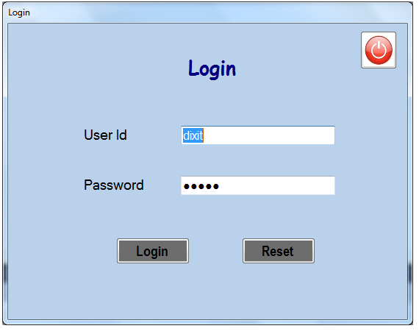
Code:

using System;
using System.Collections.Generic;
using System.ComponentModel;
using System.Data;
using System.Drawing;
using System.Linq;
using System.Text;
using System.Windows.Forms;
using System.Data .SqlClient ;
using SpeechLib;

namespace PROJECT
{

public partial class Login : Form
{
public string constr = @"Data Source=.\SQLEXPRESS;AttachDbFilename=|DataDirectory|\Airlines.mdf;Integrated Security=True;User Instance=True";
public static string un = string.Empty;
public static string un1 = string.Empty;
public Login()
{
InitializeComponent();
}
private void btnreset_Click(object sender, EventArgs e)
{
uid.Text = "";
pwd.Text = "";
}
private void btn_login_Click(object sender, EventArgs e)
{
SpVoice voice = new SpVoice();
voice.Speak("Welcome......");

SqlConnection con = new SqlConnection(constr);
con.Open();
DataTable dt = new DataTable();
SqlCommand cmd = new SqlCommand();
string str = "select * from Registration where [user_name]='"+uid.Text+"' AND [password]='"+pwd.Text+"'";
cmd.CommandText = str;
cmd.Connection = con;
SqlDataAdapter drap = new SqlDataAdapter();
drap.SelectCommand = cmd;
drap.Fill(dt);
if (uid.Text == "")//blank username
{
MessageBox.Show("Please Enter UserName", "Empty UserName Field", MessageBoxButtons.OK, MessageBoxIcon.Error);

}
else if (pwd.Text == "")//blank passs
{
MessageBox.Show("Please Enter Password", "Empty UserName Field", MessageBoxButtons.OK, MessageBoxIcon.Error);
}
else if (dt.Rows.Count > 0)
{

MessageBox.Show("Login successfully", "Login", MessageBoxButtons.OK, MessageBoxIcon.Warning);
Master m = new Master();
m.Show();
this.Close();
}
else
{
MessageBox.Show("Wrong Login name and password please, try again", "Error", MessageBoxButtons.OKCancel, MessageBoxIcon.Error);
uid.Text = "";
pwd.Text = "";
}
}
private void button2_Click(object sender, EventArgs e)
{
Application.Exit();
}

}
}

New Employee:

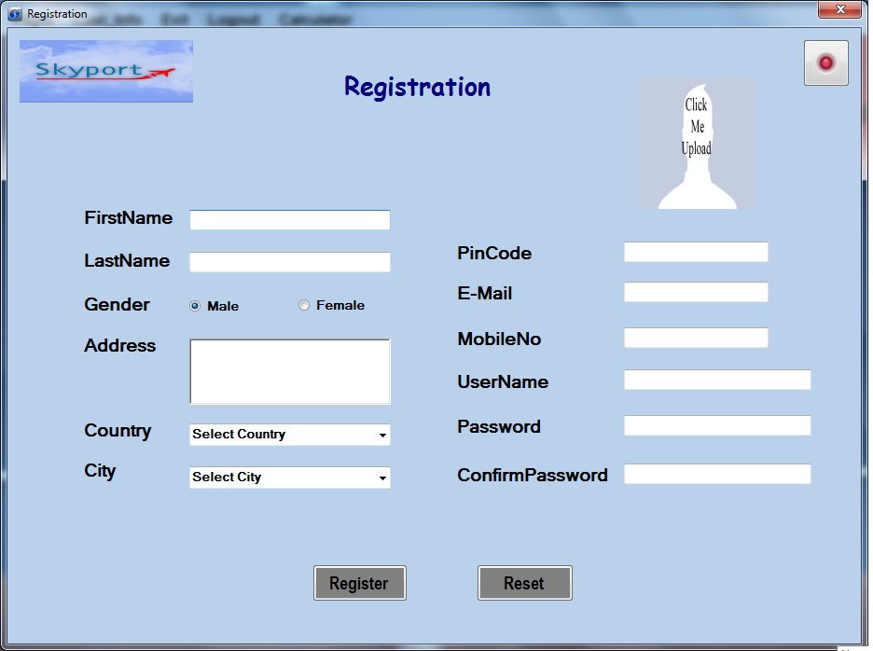
Code:
using System;
using System.Collections.Generic;
using System.ComponentModel;
using System.Data;
using System.Drawing;
using System.Linq;
using System.Text;
using System.Windows.Forms;
using System.Data.SqlClient;
using System.IO;
using System.Text.RegularExpressions;

namespace PROJECT
{

public partial class Registration : Form
{
public int im = 0;
public Registration()
{
InitializeComponent();
}

private void Registration_Load(object sender, EventArgs e)
{
im = 0;
}

private void button2_Click(object sender, EventArgs e)
{
Application.Exit();
}
private void pictureBox2_Click(object sender, EventArgs e)
{
im = 1;
openFileDialog1 .Filter = "(*.jpg)|*.jpg|,(*.png)|*.png|,(*.jpeg)|*.jpeg";
openFileDialog1 .ShowDialog();
string st = openFileDialog1.FileName;
string ss = Convert.ToString(st);
pictureBox2.ImageLocation = ss;
}

private void button1_Click(object sender, EventArgs e)
{

if (im == 0)
{
MessageBox.Show("Please Select Image", "Select Image", MessageBoxButtons.OK, MessageBoxIcon.Information);
}
else if (r_fn.Text == "" || r_ln.Text == "" || r_em.Text == "" || r_cp.Text == "" || r_pi.Text == "" || r_unm.Text == "" || r_add.Text == "" || r_mo.Text == "" || r_pa.Text == "" || r_pi.Text == "")
{
MessageBox.Show("Please Enter Deatail", "Empty Field", MessageBoxButtons.OK, MessageBoxIcon.Information);
}
else if (r_co.Text == "Select Country" || r_ci.Text == "Select City")
{
MessageBox.Show("Please Select Country & City", "Select", MessageBoxButtons.OK, MessageBoxIcon.Information);
}
else if (r_pa.Text != r_cp.Text)
{
MessageBox.Show("Please Enter Valid Password", "Passqord Not Valid", MessageBoxButtons.OK, MessageBoxIcon.Error);

}

else
{
string x = "";
if (radioButton1.Checked == true)
{
x = radioButton1.Text;
}
else
{
x = radioButton2.Text;
}
string c1 = r_co.Text;
string c2 = r_ci.Text;

SqlConnection con = new SqlConnection(@"Data Source=.\SQLEXPRESS;AttachDbFilename=|DataDirectory|\Airlines.mdf;Integrated Security=True;User Instance=True");
con.Open();

MemoryStream stream = new MemoryStream();
pictureBox2.Image.Save(stream, System.Drawing.Imaging.ImageFormat.Jpeg);
byte[] img = stream.ToArray();

SqlCommand cmd = new SqlCommand("insert into Registration(firstname,lastname,gender,address,country,city,pincode,email_id,mobileno,user_name,password,confirmpassword,photo)values('" + r_fn.Text + "','" + r_ln.Text + "','" + x + "','" + r_add.Text + "','" + c1 + "','" + c2 + "','" + r_pi.Text + "','" + r_em.Text + "','" + r_mo.Text + "','" + r_unm.Text + "','" + r_pa.Text + "','" + r_cp.Text + "',@img)", con);
cmd.Parameters.AddWithValue("img", img);
cmd.ExecuteNonQuery();

MessageBox.Show("Register successfully", "Registration", MessageBoxButtons.OK, MessageBoxIcon.Warning);

r_fn.Text = "";
r_ln.Text = "";
r_em.Text = "";
r_mo.Text = "";
r_pa.Text = "";
r_unm.Text = "";
r_pi.Text = "";
r_add.Text = "";
//r_co.Text = "";
r_cp.Text = "";
this.Close();

pictureBox2.ImageLocation = "";
Form1 f = new Form1();
f.Show();
}
}

private void button2_Click_1(object sender, EventArgs e)
{
Application.Exit();
}

private void r_reset_Click(object sender, EventArgs e)
{
r_fn.Text = "";
r_ln.Text ="";
r_em.Text = "";
r_mo.Text = "";
r_pa .Text ="";
r_unm.Text = "";
r_pi.Text = "";
r_add.Text = "";
//r_co.Text = "";
r_cp.Text = "";
r_co.Text = "Select Country";
r_ci.Text = "Select City";

}

private void button2_Click_2(object sender, EventArgs e)
{
this.Close();
}

private void r_fn_KeyPress(object sender, KeyPressEventArgs e)
{
Program p = new Program ();
p.onlyletter(e);
}

private void r_mo_KeyPress(object sender, KeyPressEventArgs e)
{
Program obj = new Program();
obj.onlydigit(e);
}

private void r_ln_KeyPress(object sender, KeyPressEventArgs e)
{
Program p = new Program();
p.onlyletter(e);
}

private void r_pi_KeyPress(object sender, KeyPressEventArgs e)
{
Program obj = new Program();
obj.onlydigit(e);
}

private void r_unm_KeyPress(object sender, KeyPressEventArgs e)
{
Program p = new Program();
p.onlyletter(e);
}

private void r_co_SelectedValueChanged(object sender, EventArgs e)
{
r_ci.Text="";
if (r_co.SelectedItem.ToString() == "India")
{
r_ci.Text = "Ahmedabad";
r_ci.Items.Clear();
r_ci.Items.Add("Ahmedabad");
r_ci.Items.Add("Delhi");
r_ci.Items.Add("Bangluru");
r_ci.Items.Add("Bombay");
}
if (r_co.SelectedItem.ToString() == "America")
{
r_ci.Text = "New York";
r_ci.Items.Clear();
r_ci.Items.Add("New York");
r_ci.Items.Add("Los Angeles");
r_ci.Items.Add("Houston(honesty)");
r_ci.Items.Add("San Diego");
}
if (r_co.SelectedItem.ToString() == "Africa")
{
r_ci.Text = "Marrakech";
r_ci.Items.Clear();
r_ci.Items.Add("Marrakech");
r_ci.Items.Add("Cape Town");
r_ci.Items.Add("Cairo");
r_ci.Items.Add("Johannesburg");
}
if (r_co.SelectedItem.ToString() == "France")
{
r_ci.Text = "Paris";
r_ci.Items.Clear();
r_ci.Items.Add("Paris");
r_ci.Items.Add("Marseille");
r_ci.Items.Add("Lyon");
r_ci.Items.Add("Toulouse");
}
}

private void r_em_Leave(object sender, EventArgs e)
{
string expression = default(string);
expression = "^([0-9a-zA-Z]([-\\.\\w]*[0-9a-zA-Z])*@([0-9a-zA-Z][-\\w]*[0-9a-zA-Z]\\.)+[a-zA-Z]{2,9})$";
if (Regex.IsMatch(r_em.Text, expression))
{

}
else
{
MessageBox.Show("Please Enter Valid Email", "Email Not Valid", MessageBoxButtons.OK, MessageBoxIcon.Error);
}

}

}
}

Booking :

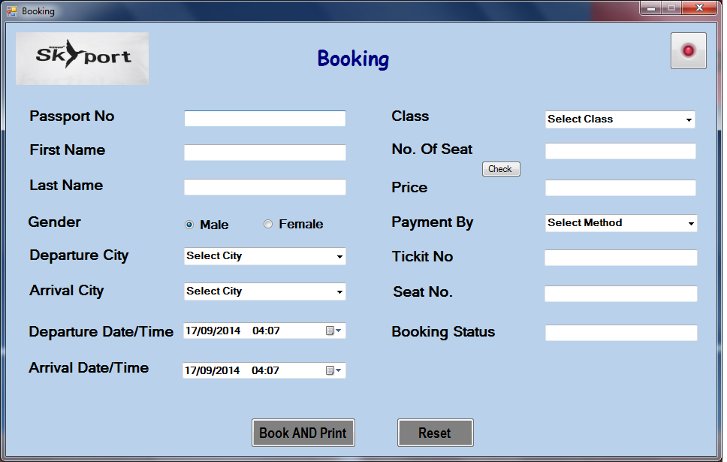

Code:

using System;
using System.Collections.Generic;
using System.ComponentModel;
using System.Data;
using System.Drawing;
using System.Linq;
using System.Text;
using System.Windows.Forms;
using System.Data.SqlClient;

namespace PROJECT
{
public partial class Booking : Form
{
private int p;
SqlConnection con = new SqlConnection(@"Data Source=.\SQLEXPRESS;AttachDbFilename=|DataDirectory|\Airlines.mdf;Integrated Security=True;User Instance=True");
public Booking()
{
InitializeComponent();
}
onepara o = new onepara();
private void btn_book_Click(object sender, EventArgs e)
{

if (b_tn.Text != "")
{
DataTable dt = new DataTable();
SqlCommand cmd = new SqlCommand();
string str = "select * from Booking where [tn]='" + b_tn.Text + "'";
cmd.CommandText = str;

SqlDataAdapter drap = new SqlDataAdapter();
drap.SelectCommand = cmd;
cmd.Connection = con;
drap.Fill(dt);
if (dt.Rows.Count > 0)
{
MessageBox.Show("Tickit No. Allready Exist.", "Invalid Tickit No.", MessageBoxButtons.OK, MessageBoxIcon.Error);
}

}

if (b_fn.Text == "" || b_nm.Text == "" || b_nos.Text == "" || txtpass.Text == "" || b_pr.Text == "" || b_tn.Text == "")
{
MessageBox.Show("Please Enter Deatail", "Empty Field", MessageBoxButtons.OK, MessageBoxIcon.Error);
}
if (comboBox1.Text == "Select City" || comboBox2.Text == "Select City")
{
MessageBox.Show("Please Select City", "Select City", MessageBoxButtons.OK, MessageBoxIcon.Error);

}
if (b_cla.Text == "Select Class")
{
MessageBox.Show("Please Select Class", "Select Class", MessageBoxButtons.OK, MessageBoxIcon.Error);

}
if (comboBox3.Text == "Select Method")
{
MessageBox.Show("Please Select Method", "Select Method", MessageBoxButtons.OK, MessageBoxIcon.Error);

}
else
{
string x = "";
if (radioButton1.Checked == true)
{
x = radioButton1.Text;
}
else
{
x = radioButton2.Text;
}

SqlConnection con = new SqlConnection(@"Data Source=.\SQLEXPRESS;AttachDbFilename=|DataDirectory|\Airlines.mdf;Integrated Security=True;User Instance=True");
con.Open();
SqlCommand cmd = new SqlCommand("insert into Booking(pno,fn,ln,gnd,dcity,acity,pb,ddate,adate,class,nos,price,tn,sn,bs)values('"+txtpass.Text+"','"+b_nm.Text+"','"+b_fn.Text+"','"+x+"','"+comboBox1.Text+"','"+comboBox2.Text+"','"+comboBox3.Text+"','"+dateTimePicker1.Text+ "','"+dateTimePicker2.Text+"','"+b_cla.Text+"','"+b_nos.Text+"','"+b_pr.Text+"','"+b_tn.Text+"','"+b_sn.Text+"','"+b_bs.Text+"')", con);

cmd.ExecuteNonQuery();

MessageBox.Show("Booking Successfully", "Booking", MessageBoxButtons.OK, MessageBoxIcon.Warning);
con.Close();
DISPLAY_TICKET d = new DISPLAY_TICKET();
d.Show();
b_fn.Text = "";
b_nm.Text = "";
b_nos.Text = "";
b_pr.Text = "";
b_tn.Text = "";
txtpass.Text = "";
b_sn.Text = "";
comboBox1.Text = "Select City";
comboBox2.Text = "Select City";
comboBox3.Text = "Select Method";
b_cla.Text = "Select Class";
b_bs.Text = "Not Booked";

}
}

private void r_reset_Click(object sender, EventArgs e)
{

b_fn.Text = "";
b_nm.Text = "";
b_nos.Text = "";
b_pr.Text = "";
b_tn.Text = "";
txtpass.Text = "";
b_sn.Text = "";
comboBox1.Text = "Select City";
comboBox2.Text = "Select City";
comboBox3.Text = "Select Method";
b_cla.Text = "Select Class";
b_bs.Text = "Not Booked";
}

private void button2_Click(object sender, EventArgs e)
{
Application.Exit();
}

private void button2_Click_1(object sender, EventArgs e)
{
this.Close();
}

private void txtpass_KeyPress(object sender, KeyPressEventArgs e)
{
Program obj = new Program();
obj.onlydigit(e);
}

private void b_nm_KeyPress(object sender, KeyPressEventArgs e)
{
Program p = new Program();
p.onlyletter(e);
}

private void b_fn_KeyPress(object sender, KeyPressEventArgs e)
{
Program p = new Program();
p.onlyletter(e);
}

private void b_nos_KeyPress(object sender, KeyPressEventArgs e)
{
Program obj = new Program();
obj.onlydigit(e);

}

private void b_pr_KeyPress(object sender, KeyPressEventArgs e)
{
Program obj = new Program();
obj.onlydigit(e);
}

private void b_tn_KeyPress(object sender, KeyPressEventArgs e)
{
Program obj = new Program();
obj.onlydigit(e);
}

private void comboBox1_Enter(object sender, EventArgs e)
{
SqlConnection con = new SqlConnection(@"Data Source=.\SQLEXPRESS;AttachDbFilename=|DataDirectory|\Airlines.mdf;Integrated Security=True;User Instance=True");
con.Open();
DataTable dt = new DataTable();
SqlCommand cmd = new SqlCommand();
string str = "select DISTINCT [fromcity] from Route";

cmd.CommandText = str;
cmd.Connection = con;
SqlDataAdapter drap = new SqlDataAdapter();
drap.SelectCommand = cmd;
drap.Fill(dt);
comboBox1.Items.Clear();
foreach (DataRow dr in dt.Rows)
{

comboBox1.Items.Add(dr[0].ToString());

}

}

private void comboBox2_Enter(object sender, EventArgs e)
{
SqlConnection con = new SqlConnection(@"Data Source=.\SQLEXPRESS;AttachDbFilename=|DataDirectory|\Airlines.mdf;Integrated Security=True;User Instance=True");
con.Open();
DataTable dt = new DataTable();
SqlCommand cmd = new SqlCommand();
string str = "select DISTINCT [tocity] from Route";

cmd.CommandText = str;
cmd.Connection = con;
SqlDataAdapter drap = new SqlDataAdapter();
drap.SelectCommand = cmd;
drap.Fill(dt);
comboBox2.Items.Clear();
foreach (DataRow dr in dt.Rows)
{

comboBox2.Items.Add(dr[0].ToString());
}

}

private void comboBox2_Leave(object sender, EventArgs e)
{
SqlConnection con = new SqlConnection(@"Data Source=.\SQLEXPRESS;AttachDbFilename=|DataDirectory|\Airlines.mdf;Integrated Security=True;User Instance=True");
con.Open();
DataTable dt = new DataTable();
SqlCommand cmd = new SqlCommand();
string str = "select id from Route where fromcity='"+comboBox1.Text+"' and tocity='"+comboBox2.Text+"'";

cmd.CommandText = str;
cmd.Connection = con;
SqlDataAdapter drap = new SqlDataAdapter();
drap.SelectCommand = cmd;
drap.Fill(dt);
if (dt.Rows.Count < 1)
{
MessageBox.Show("Route doesn't Exist....", "Invalid Route", MessageBoxButtons.OK, MessageBoxIcon.Error);
}

}

private void button1_Click(object sender, EventArgs e)
{
if (b_nos.Text == "")
{
MessageBox.Show("Please Enter NO.OF SEAT", "Empty NOS", MessageBoxButtons.OK, MessageBoxIcon.Error);

}
else
{
string date1 = String.Format("{0: dd/MM/yyyy}", dateTimePicker1.Value);

// MessageBox.Show(date1);
DataTable dt = new DataTable();
SqlCommand cmd = new SqlCommand();
SqlDataAdapter adp = new SqlDataAdapter();
cmd.Connection = con;
cmd.CommandText = "select sum(nos) from Booking where dcity='" + comboBox1.Text + "' and acity='" + comboBox2.Text + "' and class='" + b_cla.Text + "' and ddate like '%" + date1.Trim() + "%'";
adp.SelectCommand = cmd;
adp.Fill(dt);

b_sn.Text = "";
if (dt.Rows[0][0].ToString() != "")
{
if (comboBox1.Text != comboBox2.Text)
{
if (b_cla.Text == "Business")
{
for (int a = int.Parse(dt.Rows[0][0].ToString()); a <= int.Parse(b_nos.Text) + int.Parse(dt.Rows[0][0].ToString()) - 1; a++)
{
b_sn.Text += a.ToString() + " ";
}
}
if (b_cla.Text == "Economy")
{
for (int a = int.Parse(dt.Rows[0][0].ToString()); a <= int.Parse(b_nos.Text) + int.Parse(dt.Rows[0][0].ToString()) - 1; a++)
{
b_sn.Text += a.ToString() + " ";
}
}
if (b_cla.Text == "First")
{
for (int a = int.Parse(dt.Rows[0][0].ToString()); a <= int.Parse(b_nos.Text) + int.Parse(dt.Rows[0][0].ToString()) - 1; a++)
{
b_sn.Text += a.ToString() + " ";
}
}

}
else
{
MessageBox.Show("Please Select City", "Select City", MessageBoxButtons.OK, MessageBoxIcon.Error);
}

}
else
{
if (comboBox1.Text != comboBox2.Text)
{

if (b_cla.Text == "Business")
{
for (int a = 1; a <= int.Parse(b_nos.Text); a++)
{
b_sn.Text += a.ToString() + " ";
}
}
if (b_cla.Text == "Economy")
{
for (int a = 1; a <= int.Parse(b_nos.Text); a++)
{
b_sn.Text += a.ToString() + " ";
}
}
if (b_cla.Text == "First")
{
for (int a = 1; a <= int.Parse(b_nos.Text); a++)
{
b_sn.Text += a.ToString() + " ";
}
}

}
else
{
MessageBox.Show("Please Select City", "Select City", MessageBoxButtons.OK, MessageBoxIcon.Error);
}

}

}

}

private void b_cla_Enter(object sender, EventArgs e)
{
if (comboBox1.Text == "Select City" || comboBox2.Text == "Select City")
{
MessageBox.Show("Please Select City", "Select City", MessageBoxButtons.OK, MessageBoxIcon.Error);

}

}

private void b_nos_Enter(object sender, EventArgs e)
{
if (b_cla.Text == "Select Class")
{
MessageBox.Show("Please Select Class", "Select Class", MessageBoxButtons.OK, MessageBoxIcon.Error);

}

}

private void comboBox3_Leave(object sender, EventArgs e)
{
b_bs.Text = "Booked";
}

private void txtpass_Leave(object sender, EventArgs e)
{
con.Open();
SqlCommand cmd = new SqlCommand("select * from Booking where pno='" + txtpass.Text + "'", con);
SqlDataReader dr;
dr = cmd.ExecuteReader();
if (dr.HasRows)
{
while (dr.Read())
{
b_nm.Text=dr[2].ToString ();
b_fn.Text =dr[3].ToString ();
}
}
con.Close();

}

private void b_pr_Enter(object sender, EventArgs e)
{
SqlCommand cmd = new SqlCommand();
SqlDataAdapter adp = new SqlDataAdapter();
DataTable dt = new DataTable();
cmd.Connection = con;
cmd.CommandText = "select [dis] from route where fromcity='" + comboBox1.Text + "' and tocity='" + comboBox2.Text + "' ";
adp.SelectCommand = cmd;
adp.Fill(dt);
if (dt.Rows.Count > 0)
{
int distn = int.Parse(dt.Rows[0][0].ToString());
if (b_cla.Text == "Business")
{
int a = int.Parse(b_nos.Text);
b_pr.Text = Convert.ToString(a * 10 * distn);
}
if (b_cla.Text == "First")
{

int a = int.Parse(b_nos.Text);
b_pr.Text = Convert.ToString(a * 7 * distn);
}
if (b_cla.Text == "Economy")
{

int a = int.Parse(b_nos.Text);
b_pr.Text = Convert.ToString(a * 5 * distn);
}
}
}
}
}

New Flight

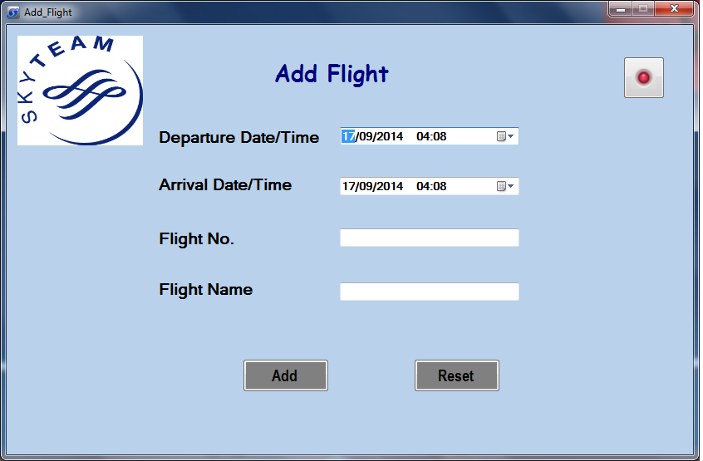

Code:

using System;
using System.Collections.Generic;
using System.ComponentModel;
using System.Data;
using System.Drawing;
using System.Linq;
using System.Text;
using System.Windows.Forms;
using System.Data .SqlClient ;

namespace PROJECT
{
public partial class Add_Flight : Form
{
public Add_Flight()
{
InitializeComponent();
}

private void Flight_Load(object sender, EventArgs e)
{

}
private void button2_Click_1(object sender, EventArgs e)
{
Application.Exit();
}

private void btnadd_Click(object sender, EventArgs e)
{
if (f_fn.Text == "" || f_fnm.Text == "")
{
MessageBox.Show("Please Enter Deatail", "Empty Field", MessageBoxButtons.OK, MessageBoxIcon.Error);
}
else
{
SqlConnection con = new SqlConnection(@"Data Source=.\SQLEXPRESS;AttachDbFilename=|DataDirectory|\Airlines.mdf;Integrated Security=True;User Instance=True");
con.Open();
SqlCommand cmd = new SqlCommand("insert into Flight values('"+d_time.Text+"','"+a_time.Text+"','"+f_fn.Text+"','"+f_fnm.Text+"')", con);
cmd.ExecuteNonQuery();
MessageBox.Show("Flight Added successfully", "Flight", MessageBoxButtons.OK, MessageBoxIcon.Warning);
f_fn .Text = "";
f_fnm .Text = "";
}
}

private void f_fn_KeyPress(object sender, KeyPressEventArgs e)
{
Program obj = new Program();
obj.onlydigit(e);
}

private void f_fnm_KeyPress(object sender, KeyPressEventArgs e)
{
Program p = new Program();
p.onlyletter(e);
}

private void btnre_Click(object sender, EventArgs e)
{
f_fnm.Text = "";
f_fn.Text = "";
}

private void button2_Click(object sender, EventArgs e)
{
this.Hide();
}
}
}

New Route:

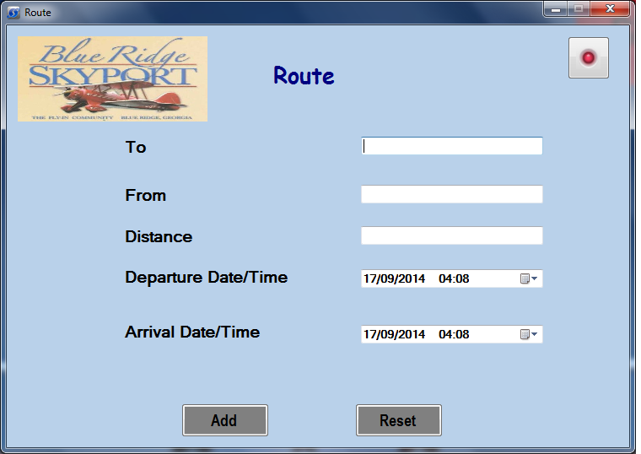

Code:

using System;
using System.Collections.Generic;
using System.ComponentModel;
using System.Data;
using System.Drawing;
using System.Linq;
using System.Text;
using System.Windows.Forms;
using System.Data.SqlClient;

namespace PROJECT
{
public partial class Route : Form
{
public Route()
{
InitializeComponent();
}

private void button2_Click(object sender, EventArgs e)
{
Application.Exit();
}

private void btnadd_Click(object sender, EventArgs e)
{

SqlConnection con = new SqlConnection(@"Data Source=.\SQLEXPRESS;AttachDbFilename=|DataDirectory|\Airlines.mdf;Integrated Security=True;User Instance=True");
if (r_from.Text == "" || r_to.Text == ""|| r_dis.Text == "")
{
MessageBox.Show("Please Enter Deatail", "Empty Field", MessageBoxButtons.OK, MessageBoxIcon.Error);
}

else
{

con.Open();

SqlCommand cd = new SqlCommand("insert into Route values('"+r_to.Text+"','"+r_from.Text+"','"+r_dis.Text+"','"+ d_date.Text+"','"+a_date.Text+"')", con);
cd.ExecuteNonQuery();

MessageBox.Show("Route Added successfully", "Route", MessageBoxButtons.OK, MessageBoxIcon.Warning);
r_to.Text = "";
r_from.Text = "";
r_dis.Text = "";

}
}

private void btnre_Click(object sender, EventArgs e)
{
r_to.Text = "";
r_from.Text = "";
r_dis.Text = "";
}

private void button2_Click_1(object sender, EventArgs e)
{
this.Close();
}

private void r_to_KeyPress(object sender, KeyPressEventArgs e)
{
Program p = new Program();
p.onlyletter(e);

}

private void r_from_KeyPress(object sender, KeyPressEventArgs e)
{
Program p = new Program();
p.onlyletter(e);
}
}
}

Cancel Ticket:-

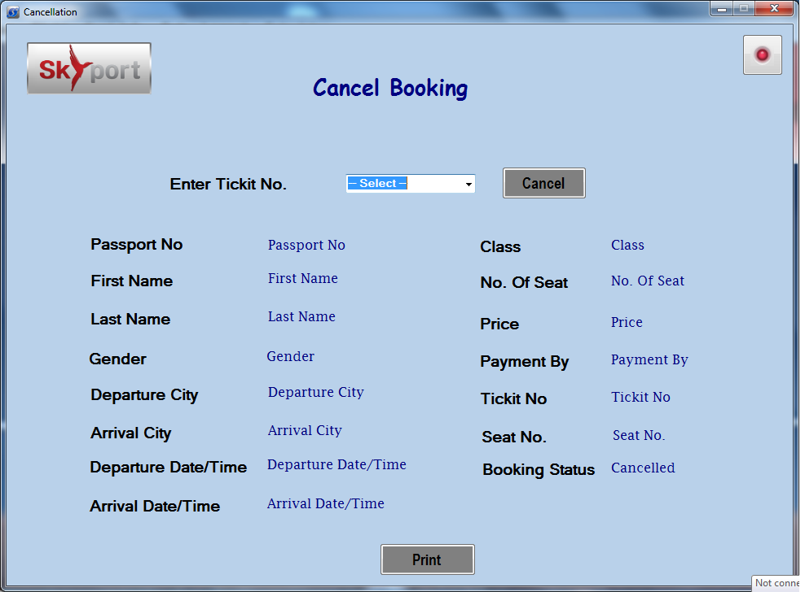

Code:

using System;
using System.Collections.Generic;
using System.ComponentModel;
using System.Data;
using System.Drawing;
using System.Linq;
using System.Text;
using System.Windows.Forms;
using System.Data.SqlClient;

namespace PROJECT
{
public partial class Cancellation : Form
{
public Cancellation()
{
InitializeComponent();
}

private void button2_Click(object sender, EventArgs e)
{
Application.Exit();
}

private void txtnic_KeyPress(object sender, KeyPressEventArgs e)
{
Program obj = new Program();
obj.onlydigit(e);
}

private void comboBox1_Enter(object sender, EventArgs e)
{
SqlConnection con = new SqlConnection(@"Data Source=.\SQLEXPRESS;AttachDbFilename=|DataDirectory|\Airlines.mdf;Integrated Security=True;User Instance=True");
con.Open();
DataTable dt = new DataTable();
SqlCommand cmd = new SqlCommand();
string str = "select [tn] from Booking";

cmd.CommandText = str;
cmd.Connection = con;
SqlDataAdapter drap = new SqlDataAdapter();
drap.SelectCommand = cmd;
drap.Fill(dt);
comboBox1.Items.Clear();
foreach (DataRow dr in dt.Rows)
{

comboBox1.Items.Add(dr[0].ToString());

}
}

private void btn_del_Click(object sender, EventArgs e)
{
Global_Class.cn = comboBox1.Text;
if (comboBox1.Text == "-- Select --")
{
MessageBox.Show("Please Select Customer Tickit No.", "Empty Field", MessageBoxButtons.OK, MessageBoxIcon.Error);
}
else
{
DialogResult dr1 = MessageBox.Show("Are You Sure To Cancel.......?", "SkyPort Atrlines", MessageBoxButtons.YesNo, MessageBoxIcon.Question, MessageBoxDefaultButton.Button2 );
SqlConnection con = new SqlConnection(@"Data Source=.\SQLEXPRESS;AttachDbFilename=|DataDirectory|\Airlines.mdf;Integrated Security=True;User Instance=True");
con.Open();

SqlCommand a = new SqlCommand("select * from Booking where tn='" + comboBox1.Text + "'", con);
SqlDataReader dr;
dr = a.ExecuteReader();
if (dr.HasRows)
{
while (dr.Read())
{
pno.Text = dr[1].ToString();
fnm.Text = dr[2].ToString();
lnm.Text = dr[3].ToString();
gnd.Text = dr[4].ToString();
dct.Text = dr[5].ToString();
act.Text = dr[6].ToString();
dtm.Text = dr[7].ToString();
atm.Text = dr[8].ToString();
cls.Text = dr[9].ToString();
nos.Text = dr[10].ToString();
prc.Text = dr[11].ToString();
tno.Text = dr[12].ToString();
sno.Text = dr[13].ToString();
pby.Text = dr[14].ToString();

}
con.Close();
}
if (dr1 == DialogResult.Yes)
{

con.Open();
DISPLAY_CANCEL_TICKET dc = new DISPLAY_CANCEL_TICKET();
dc.Show();
SqlCommand cmd = new SqlCommand("delete from Booking where tn='" + comboBox1.Text + "' ", con);
cmd.ExecuteNonQuery();

MessageBox.Show("Booking Cancel Successfully.", "Cancel Booking", MessageBoxButtons.OK, MessageBoxIcon.Asterisk);
con.Close();
}
else
{
MessageBox.Show("Sorry........");
}

}
}

private void button2_Click_1(object sender, EventArgs e)
{
this.Hide();
}

}
}

Employee Information

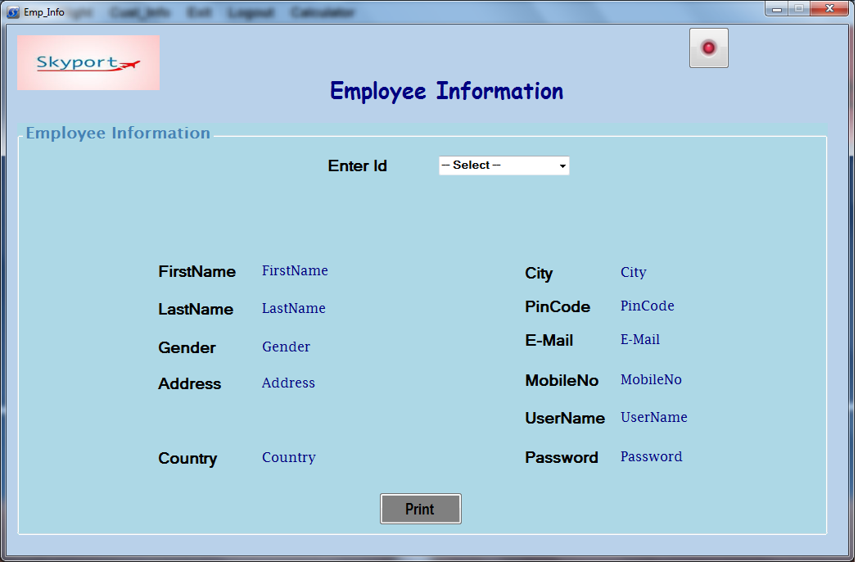

Code:

using System;
using System.Collections.Generic;
using System.ComponentModel;
using System.Data;
using System.Drawing;
using System.Linq;
using System.Text;
using System.Windows.Forms;
using System .Data .SqlClient ;
using System.IO;

namespace PROJECT
{
public partial class Emp_Info : Form
{
public Emp_Info()
{
InitializeComponent();
}

private void button2_Click(object sender, EventArgs e)
{
Application.Exit();
}

private void button2_Click_1(object sender, EventArgs e)
{
this.Close();
}

private void txtnic_KeyPress(object sender, KeyPressEventArgs e)
{
Program obj = new Program();
obj.onlydigit(e);
}

private void comboBox1_SelectedIndexChanged(object sender, EventArgs e)
{
Global_Class.empid = comboBox1.Text;
SqlConnection con = new SqlConnection(@"Data Source=.\SQLEXPRESS;AttachDbFilename=|DataDirectory|\Airlines.mdf;Integrated Security=True;User Instance=True");

con.Close();
con.Open();
SqlDataAdapter ad = new SqlDataAdapter("select photo from Registration where id='" + comboBox1.Text + "'", con);
DataSet ds = new DataSet();
ad.Fill(ds, "Registration");
if (ds.Tables["Registration"].Rows.Count > 0)
{

MemoryStream ms = new MemoryStream((byte[])ds.Tables["Registration"].Rows[0]["photo"]);
ms.Position = 0;

pictureBox2.Image = Image.FromStream(ms);
}
SqlCommand a = new SqlCommand("select * from Registration where id='" + comboBox1.Text + "'", con);
SqlDataReader dr;
dr = a.ExecuteReader();
if (dr.HasRows)
{
while (dr.Read())
{
fnm.Text = dr[1].ToString();
lnm.Text = dr[2].ToString();
gnd.Text = dr[3].ToString();
add.Text = dr[4].ToString();
cou.Text = dr[5].ToString();
cty.Text = dr[6].ToString();
pin.Text = dr[7].ToString();
eml.Text = dr[8].ToString();
mob.Text = dr[9].ToString();
unm.Text = dr[10].ToString();
pwd.Text = dr[11].ToString();
}
}

}

private void comboBox1_Enter(object sender, EventArgs e)
{
SqlConnection con = new SqlConnection(@"Data Source=.\SQLEXPRESS;AttachDbFilename=|DataDirectory|\Airlines.mdf;Integrated Security=True;User Instance=True");
con.Open();
DataTable dt = new DataTable();
SqlCommand cmd = new SqlCommand();
string str = "select [id] from Registration";

cmd.CommandText = str;
cmd.Connection = con;
SqlDataAdapter drap = new SqlDataAdapter();
drap.SelectCommand = cmd;
drap.Fill(dt);
comboBox1.Items.Clear();
foreach (DataRow dr in dt.Rows)
{

comboBox1.Items.Add(dr[0].ToString());

}
}

private void button3_Click(object sender, EventArgs e)
{
this.Hide();
}

private void button1_Click(object sender, EventArgs e)
{
Display_Emp_Info ef = new Display_Emp_Info();
ef.Show();
}
}
}

Flight Information

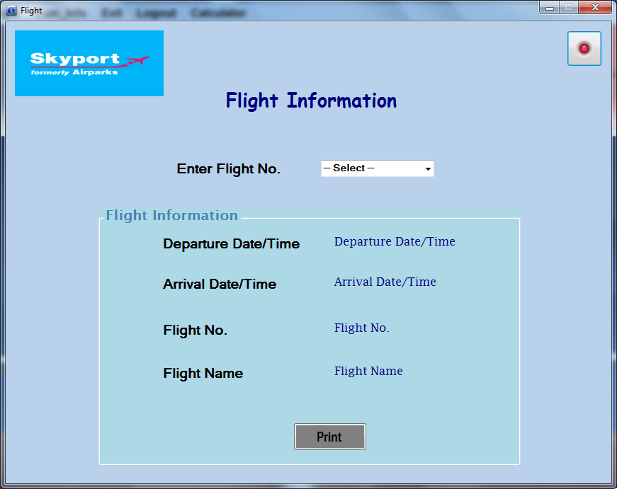

Code:

using System;
using System.Collections.Generic;
using System.ComponentModel;
using System.Data;
using System.Drawing;
using System.Linq;
using System.Text;
using System.Windows.Forms;
using System.Data.SqlClient ;
namespace PROJECT
{
public partial class Flight_Info : Form
{
public Flight_Info()
{
InitializeComponent();
}

private void button2_Click(object sender, EventArgs e)
{
Application.Exit();
}

private void button2_Click_1(object sender, EventArgs e)
{
this.Close();
}

private void txtnic_KeyPress(object sender, KeyPressEventArgs e)
{
Program obj = new Program();
obj.onlydigit(e);
}

private void comboBox1_SelectedIndexChanged(object sender, EventArgs e)
{
SqlConnection con = new SqlConnection(@"Data Source=.\SQLEXPRESS;AttachDbFilename=|DataDirectory|\Airlines.mdf;Integrated Security=True;User Instance=True");
con.Open();
Global_Class.flightno = comboBox1.Text;
SqlCommand a = new SqlCommand("select * from Flight where fno='" + comboBox1.Text + "'", con);
SqlDataReader dr;
dr = a.ExecuteReader();
if (dr.HasRows)
{
while (dr.Read())
{
dtm.Text = dr[0].ToString();
atm.Text = dr[1].ToString();
fno.Text = dr[2].ToString();
fnm.Text = dr[3].ToString();

}
}
}

private void comboBox1_Enter(object sender, EventArgs e)
{
SqlConnection con = new SqlConnection(@"Data Source=.\SQLEXPRESS;AttachDbFilename=|DataDirectory|\Airlines.mdf;Integrated Security=True;User Instance=True");
con.Open();
DataTable dt = new DataTable();
SqlCommand cmd = new SqlCommand();
string str = "select [fno] from Flight";

cmd.CommandText = str;
cmd.Connection = con;
SqlDataAdapter drap = new SqlDataAdapter();
drap.SelectCommand = cmd;
drap.Fill(dt);
comboBox1.Items.Clear();
foreach (DataRow dr in dt.Rows)
{

comboBox1.Items.Add(dr[0].ToString());

}

}
private void print_Click(object sender, EventArgs e)
{

Display_Flight_Info dfi = new Display_Flight_Info();
dfi.Show();

}
}
}

Custmore Information:

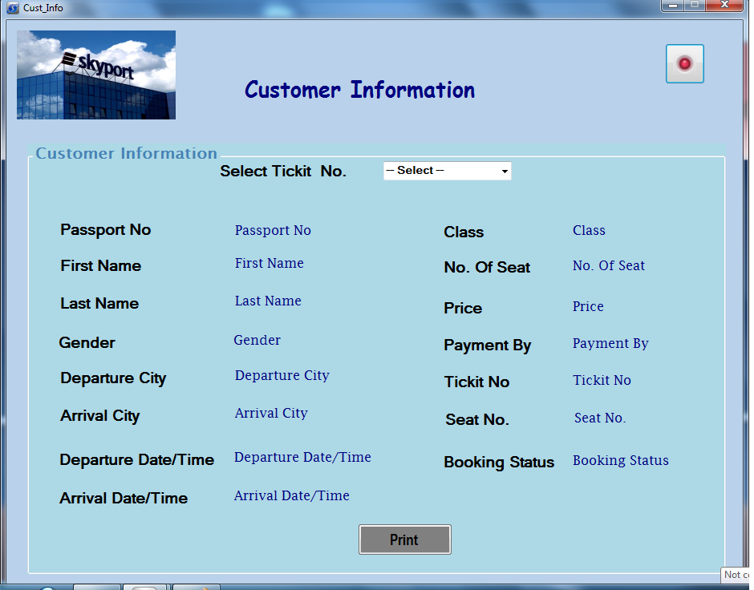

Code:
using System;
using System.Collections.Generic;
using System.ComponentModel;
using System.Data;
using System.Drawing;
using System.Linq;
using System.Text;
using System.Windows.Forms;
using System.Data.SqlClient;

namespace PROJECT
{
public partial class Cust_Info : Form
{
public Cust_Info()
{
InitializeComponent();
}

private void button2_Click(object sender, EventArgs e)
{
Application.Exit();
}
private void txtnic_KeyPress(object sender, KeyPressEventArgs e)
{
Program obj = new Program();
obj.onlydigit(e);
}

private void comboBox1_SelectedIndexChanged(object sender, EventArgs e)
{
Global_Class.ticketno = comboBox1.Text;
SqlConnection con = new SqlConnection(@"Data Source=.\SQLEXPRESS;AttachDbFilename=|DataDirectory|\Airlines.mdf;Integrated Security=True;User Instance=True");
con.Open();
SqlCommand a = new SqlCommand("select * from Booking where tn='" + comboBox1.Text + "'", con);
SqlDataReader dr;
dr = a.ExecuteReader();
if (dr.HasRows)
{
while (dr.Read())
{
pno.Text = dr[1].ToString();
fnm.Text = dr[2].ToString();
lnm.Text = dr[3].ToString();
gnd.Text = dr[4].ToString();
dct.Text = dr[5].ToString();
act.Text = dr[6].ToString();
dtm.Text = dr[7].ToString();
atm.Text = dr[8].ToString();
cls.Text = dr[9].ToString();
nos.Text = dr[10].ToString();
prc.Text = dr[11].ToString();
tno.Text = dr[12].ToString();
sno.Text = dr[13].ToString();
pby.Text = dr[14].ToString();
bst.Text = dr[15].ToString();
}
}
}

private void comboBox1_Enter(object sender, EventArgs e)
{
SqlConnection con = new SqlConnection(@"Data Source=.\SQLEXPRESS;AttachDbFilename=|DataDirectory|\Airlines.mdf;Integrated Security=True;User Instance=True");
con.Open();
DataTable dt = new DataTable();
SqlCommand cmd = new SqlCommand();
string str = "select [tn] from Booking";

cmd.CommandText = str;
cmd.Connection = con;
SqlDataAdapter drap = new SqlDataAdapter();
drap.SelectCommand = cmd;
drap.Fill(dt);
comboBox1.Items.Clear();
foreach (DataRow dr in dt.Rows)
{
comboBox1.Items.Add(dr[0].ToString());
}
}
private void button2_Click_1(object sender, EventArgs e)
{
this.Hide();
}
private void print_Click(object sender, EventArgs e)
{
DISPLAY_CUST_INFO dsi = new DISPLAY_CUST_INFO();
dsi.Show();
}

}
}

Biblography

- References:
1) Web developing using C#.net
Authors:Mayank Mankodi & group.
Publication: Bharat & com.
C#.NET Black Book

Websites:
- www.connectionstring.com
- www.codeguru.com
- www.codeproject.com
- www.stackoverflow.com
- www.ehow.com
- www.google.co.in

- www.w3cschool.com

